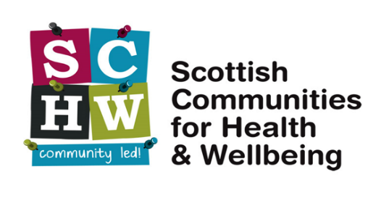
The alliance of community-led health
and wellbeing improvement organisations

‘The Big Get Together’
‘Talkin bout a Revolution: From rhetoric to action’

On 13 November 2023 around fifty people from community-led health organisations and other partners met in the Byres Community Hub, School of Health and Wellbeing, University of Glasgow. Many more would have liked to attend. They came to
- Exchange experiences of community-led health in action
- Hear new evidence of how it makes a difference
- Discuss what they can do themselves to increase their impact
- Challenge government, the NHS and others to move beyond rhetoric to support community-led action

The event explored how we can move from rhetoric to action, with insights from partners in the SCHW network, Glasgow Caledonian University, the Scottish and Northern Ireland SPRING programmes and the Scottish Government’s Place and Wellbeing programme. At the end of this document, we record some of the key messages that participants wanted to pass on about the way forward.
Workshops on several aspects of ‘community-led health in practice’ allowed discussions on innovative community led approaches and structures for securing health and wellbeing improvement across Scotland. Here we bring together the ideas recorded in those workshops, and the key messages that people wanted to pass on about the way forward at the end of the event.

Workshop A: Why local democracy matters, what can be done to improve it and what impact it might have on our sector? (Hosts: Jill Keegan, Paul Nelis)

- The group discussed where power lies within their community. Often discussions about democratic participation also refer to the allocation of funding and other resources.

- Some community councils have been given a great deal of power through the community benefit funds from windfarms. Funding is now directed through them.

- Not all community councils are well organised and, in some instances, don’t represent the community they serve.

- It is difficult for community led organisations to deliver services on the ground and maintain a representative voice at the many partnership meetings. If community organisations are not at the meetings, then it is harder to get funding. Community led organisations are stretched to the limit and often don’t have the capacity to attend strategic partnership meetings.

- The pandemic demonstrated that community led health organisations can make a significant impact if they are properly funded. Many strategic partnership groups did not meet during this time but funding was released to deliver services.

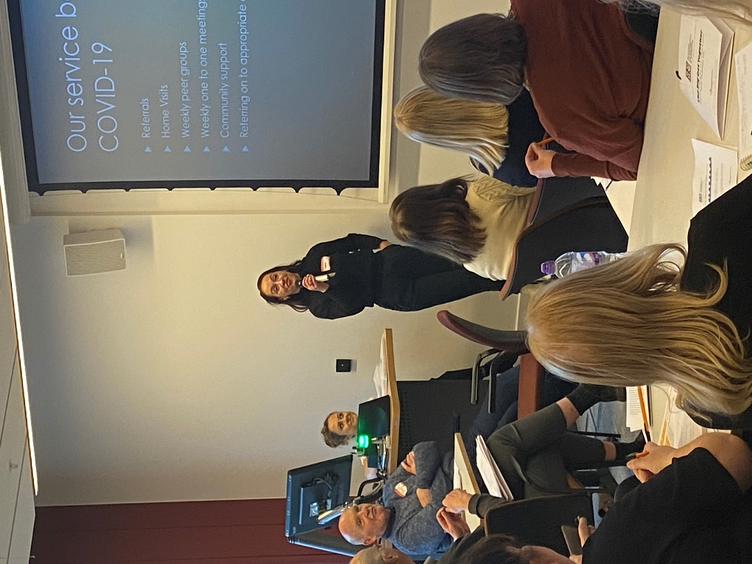

Workshop B: The future of Social Prescribing: exchanging ideas and experience of how it works in communities and how this should be developed. (Hosts: Mark Slorance, Ali Stanley)

The Rose, Thorn and Bud mindful reflection method was used to structure the workshop as this structured nature of reflection encourages individuals to be mindful of both positive and challenging aspects of their experiences. This mindfulness contributes to a more balanced perspective. Throughout our discussion participants were asked to place comments under each heading. These are noted below:

Rose: Highlighting the Successes and Positive Outcomes of a Social Prescribing Model – What has worked:

- Local Community Spaces offering support
- Promotes Positive Health and Wellbeing
- Cost Avoidance – Cost Savings for NHS
- Feeling that we are being seen and heard
- Supporting a positive change in behaviours
- Started me on my journey to volunteering
- Reduced my reliance on medications
- Building on positive relationships with NHS
- Helped people, help themselves
- Promotion of peer support, people with lived experience now helping others
- Visible positive changes with individuals
- I found it easier to speak with community workers
- Less reliance on statutory services
- Social Prescribing is a holistic approach offering wrap around support
- Social Prescribing Works!

Thorn – What were the challenges experienced
- Loss of key experienced staff
- Social “Prescribing” – a reference to the medical model
- Receiving inappropriate referrals
- Small closed peer support groups
- Lack of funding
- People not ready to engage
- Lack of wider community engagement
- Lack of recognition of the time needed to get the best out of people
- Lack of multi-year funding
- Link Worker overdose

Bud – New Ideas and Developments, what are you looking forward to?
- NHS Learning from CVS organisations
- Involvement in ongoing research
- Increased awareness of Social Prescribing and community led health
- Potential statutory funding
- Increased partnership working
- Knowledge is power
- Direct engagement with NHS trusts
- The development of new cafes and meeting places
- Continuation of Social Prescribing and peer support.
- New support sessions, chats and workshops
- Negotiation of service level agreements with NHS
- Continuing partnerships with GP Practices
- CVS should celebrate and shout about their work.

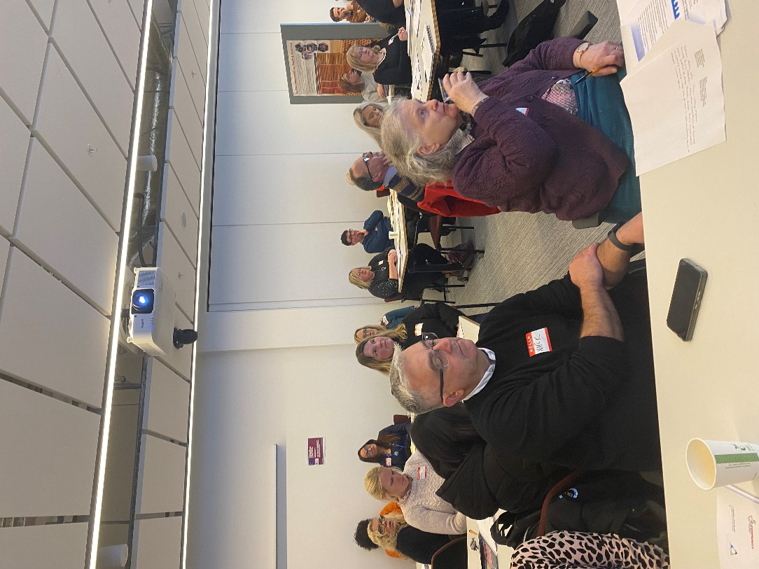
Discussion from the floor around issues relating to:
- funding ending,
- insecurities around short-term contracts
- how the 3rd sector is reliant on an ever-changing funding landscape
- how adaptable staff are expected to be i.e. changing roles, different skills in order to stay employed by and organisation they are loyal to
- additiona stress experienced by staff in relation to the above.

Feedback from Helena from UK lottery in relation to this discussion from a funders perspective: how UKL have tried to evolve the way they fund and ask for reporting on projects to be as user friendly as possible.
Group Discussion around impact of losing a dedicated SP worker: participants discussed the difficulty of keeping groups going without a dedicated member of staff driving it, managing a referral pathway, ensuring new referrals come in and that they are appropriate.
Quotes from discussion:
- Participant from a small charity, who attended to find out what SP was and how they could do it: “I think we already do it”

- “We no longer have a dedicated SP worker and it’s almost impossible to guarantee that people will progress along a journey if someone isn’t able to be on it with them.”

- “Link workers send people to us, take the credit for the progress, but have done nothing but signpost to us!”

- “We are community-based organisations, talking to the community at community level.”

- “We’re all here trying to make a difference, it shouldn’t be so difficult for us to get funding to do what we do well.”

- “It’s vital that our needs are represented at Government level, to say this is what we do, these are the benefits.”

Workshop C: Proving it: how to gather and use convincing evidence of what works. (Hosts: Jack Rendall, Julie Fox)
Key points from morning workshop:
- In most cases quantitative data is already collected and used as evidence – discussion followed on the time spent and value of this data and what it is used for (if it is useful)

- Acknowledging funders usually asked for attendance/participation numbers and this was straightforward and useful for own monitoring.

- Participants raised issue of gathering useful qualitative data - the discussion diverged and discussed the need for staff to collect ongoing data/feedback to determine if what the staff/organisation was doing (activity/process/intervention) was achieving the expected outcomes. Not to assume everything always worked. And the importance of recording unexpected outcomes. Essentially internal monitoring that is not necessary reported to funders – although some funders may find it useful.

- Discussion developed around the different tools available for collecting qualitative data – WEMWEBS, Outcome Star, the use of bespoke tools such as Elemental. There was some discussion over the meaning and use of ‘wellbeing outcomes’ and how these are used as a tool for individual/client monitoring but also collectively to report trends to funders.

- All felt simple and straightforward methods were best. Emphasis was usually on the need to feedback to funder.

- Noted that academic studies could also be a source of data for funders e.g., CommonHealth Assets project. CHEX, SCDC Glasgow Centre for Population Health. But some felt time finding and accessing this was challenging.

- Discussed that funders need to know the overall impact of their funding on people lives and that case studies are best used to explain individual outcomes and overall impact on the individual.

- Sometimes there are barriers around the language of qualitative data collection and interpretation. Important to include lived experience beneficiaries/volunteers and learn from their reflections.

- A final point was discussed regarding the equality of collecting monitoring/evaluation data and case study evidence. It was felt that the public sector (who are often the funders) do not have the same pressure/demand to collect evidence and prove what they do is making a difference.

- There should be lessons from the Covid experience – when third sector was trusted to get on with it (make a positive difference) and funded to do so. This goodwill seems to have returned to pre-Covid times.

Afternoon Workshop. Many similar points discussed at morning workshop – in addition:
- There can be barriers to collecting qualitative feedback/data e.g., time and availability. Some groups are time poor and do not prioritise time for providing feedback e.g., unpaid carers. Creative solutions needed.

- Also the pressure on staff to balance the need to meet the increase in demand for services v collecting evidence. The following point was strongly made – that everyone knows what we do works – why do we have to keep proving it?

- From a funder perspective – the importance of “evidence of need” to seek funding for a new project and funders need to know that their funds are making a positive impact on people’s lives. What difference is it making?

- Final point made about the value of both collecting evidence of impact in the short term but there is also long-term evidence that could be collected.

Workshop D: Responding to the cost-of-living crisis. (Hosts: Peter Taylor, Carol Biggin)
Participants described a variety of local experiences:
- Carol talked about her involvement in her own community and Village Hall in Renfrewshire. Increased utility bills have meant that an increase in hall letting fees is being explored. The concern there is that if regular classes incur increased costs, they will need to pass this on to class members. This could lead to people deciding to not continue attending the class, resulting in the class folding altogether.

- Boomerang Community Centre, Dundee – activities include Food Larder, Cosy Café, Lunch Club, information service including housing support. More and more Food Larders are springing up, resulting in everyone chasing the same supplies. There is still an element of ‘hard to reach’ folk who are unaware of the service (no internet etc). Partnerships with retail organisations are vital – e.g. Asda providing school clothing.

- Annexe Communities, Glasgow - provides affordable nutritious meals in café from supermarket surplus; In the process of setting up a Cost of Living support group; Social prescriber has continued in post - can offer advice/signposting re cost of living.

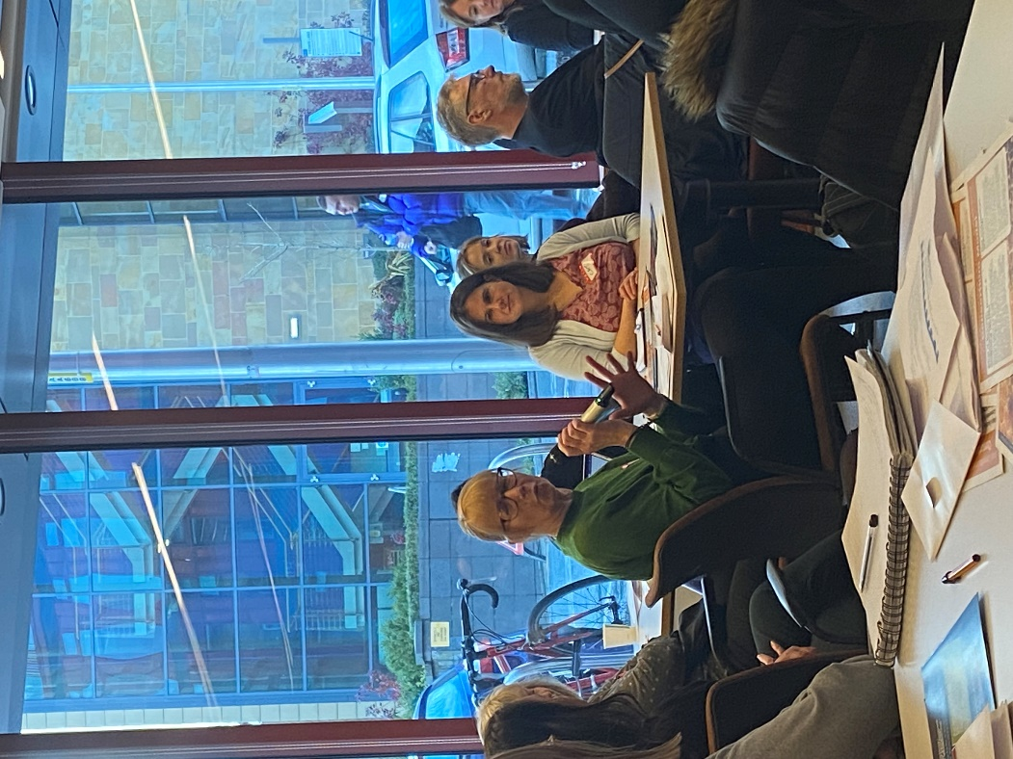

- Kingsway Community Connections, Glasgow - over last year have dealt with increased concerns re energy costs etc – ‘heat or eat’; have increased opening hours; through partnership working, provide cheap nutritious meals; provide Breakfast Club, meals, signposting and a cooker for folk to heat up meals. Current feeling is ‘just stopping things getting less bad’.

- NHS Dumfries & Galloway - Supports community groups and peer led activities. Covid has resulted in a reduction in activities. ‘Home team’ – multi disciplinary.

- North Glasgow Health Living Community: Currently ‘dealing with anything in front of you!’ Distribute soup packs. Firefighting! not doing CD work – more like family support work.

- Healthy & Active, East Kilbride - EK is perceived as an affluent town, but this is not the case for all areas. Cost of living support network set up during Covid pandemic. Stigma attached to ‘Warm Welcome’ spaces! Have used food bank infrastructure to seek those needing support – using short term funding. Just trying to make small differences.

- Central & West Integration Network, Glasgow – working mainly with asylum seekers and refugees, they offer a multi-cultural food pantry, Community Meals, drop-in advice and signposting, guided walks around useful local organisations etc.

Carol also shared two useful organisations/websites:
- In Kind Direct – www.inkinddirect.org (Distribute quality consumer products, donated by well-known UK manufacturers, retailers and brands, to charitable organisations – including charities, community groups, foodbanks and schools)
- Charity Excellence Framework - www.charityexcellence.co.uk (A free one-stop-shop for anything a charity needs – including organisation health check, funder finder, help finder and free resources.

Workshop E: Community led approaches to supporting mental health. (Hosts: Brendan Rooney, Jan Taylor)
- Wider societal and local community conditions all play a role in affecting mental health of our residents and communities. These can be negative and positive factors.
- If we look at supporting mental health in a wider wellbeing context, then all of the work that our orgs do supports mental health and wellbeing.

- There was concern that organisations, staff and volunteers don’t have the knowledge and skills to be effective mental health supporters.

- Conversely it was recognised that there are many excellent resources, training and supports available to community orgs such Mental Health First Aid, Safe Talk, Asist Training and many more.

- It was greed that the more we share knowledge and skills around supporting mental health, the more able and empowered our residents, volunteers and staff can become.

- Statutory agencies are unable to meet demand, and this is having an impact on community organisations.

- There was shared concern at the increasing levels of mental health distress in our communities and in society at large. This is at a time when our incomes are dropping, and capacity is therefore lowering.

Workshop F: The role of community led health improvement in health reform. (Robin McAlpine, John Cassidy)
- Scotland is almost unique among western European countries in having a very centralised system of national government and a huge structure of unitary authorities at a local level. The result can be seen to be really undemocratic in terms of the meaningful engagement of local communities in planning and decision making.

- Common Weal is focussed on models of local democracy which draw down powers and establish local hubs which control all service sin a local area and support community wealth building.

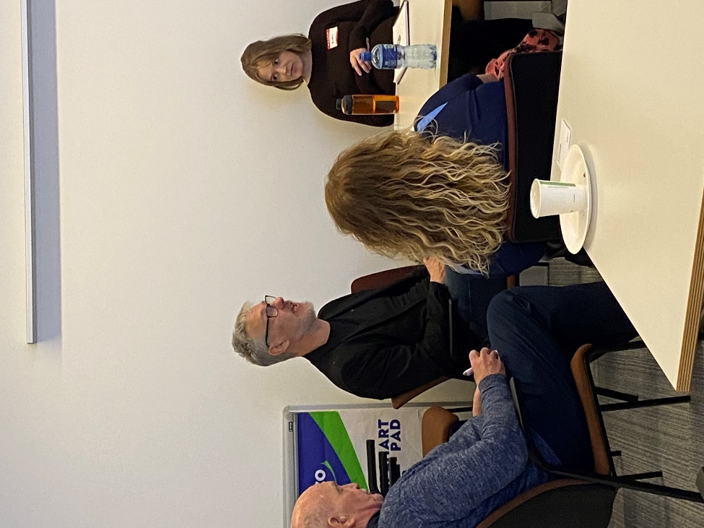
- Demand for local support for health and other services is high and growing. Agencies are stretched and more referrals to community organisations is not accompanied by more funding. GPs are overwhelmed resulting in more referrals to A and E and greater pressures on primary and secondary care in the NHS. One consequence of this is that referrals to community organisations for support feature individuals with increasingly complex needs. This puts an impossible strain on community organisations at a time when funding is reducing. Another consequence is that the demand on services means that early intervention and prevention are “out the window”.

- There is a need to mobilise the “power of political will’ in communities supported by local multiagency hubs. It is important the local “stuff’ is joined up through community hubs. Pressure on the NHS could be reduced by increasing the capacity of CLOs to respond to local health and wellbeing issues and make the NHS a service that attracts staff to fill vacancies because it provides a more satisfying career.

- To advocate change for a separation of the Care (social model) and the Health (medical model) services (they are very different in their demands and responses) there needs to be a campaign focussed on “specifics”. One which persuades politicians that the specific issues urgently need to be addressed, that they can be addressed through a carefully planned community-based strategy and that it would be in their interest to act now. Such a campaign needs to be proposed and supported by a “critical mass” of the population.

The way forward – discussion
At the end of the event people, discussed in groups what key messages they wanted to pass on about the way forward. Here are their written comments.
- A realisation that what we are already doing is making a difference to physical and mental health
- Community-led health improvement works!
- Local community anchor organisations are reactive
- Third sector is an equal partner (and should be treated as such)
- Local democracy: power being devolved to ensure health really is community led and controlled/owned

- The value of individual groups coming together – Strength in numbers! JOIN SCHW
- Wider collaboration to provide better resources
- Strength in numbers. Collaboration
- More connection to others – strength in numbers- importance of relationships – connection across Scotland – partnership/collaboration – voice being heard

- Social prescribing can be lonely - let’s share ideas and work together
- Develop the SP project/model

- Community capacity building:
  - Help to know/ get known own identity
  - Visibility/marketing
  - Build to help drive health and wellbeing in our area
- Proper training and resources for staff/volunteers to do the wide role they are expected to do
- Build awareness of community led issues/activities
- Funding/budget – Scottish Government – for local organisations/activities
- Local structures – better understanding and participation of communities/voices

- Data Sharing. Building up trust in the community
- Equity in research: University sharing knowledge and skills; funding from evidence ‘being done’ to organisations; be in touch on the ground.

This event was funded by The National Lottery Community Fund | 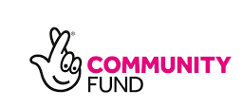

More information:
SCHW http://www.schw.co.uk/
Byres Community Hub https://www.gla.ac.uk/schools/healthwellbeing/byrescommunityhub/

